Steuermachen issues:

At the beginning, the language is always preset in German.  
The language can be changed at each step.

It lacks a home page before the benefits. This should show the user where he is located. It’s supposed to be a welcome to steuermachen. Ideally, it’s a page that has a certain wow effect.

After that, the benefits skip through by themselves.

The icons are disproportionate in the app.

If you go through the benefits, all pictures should be arranged uniformly on the page. The icons must not be too large. The structure of the benefits looks unprofessional. The text doesn’t look professional

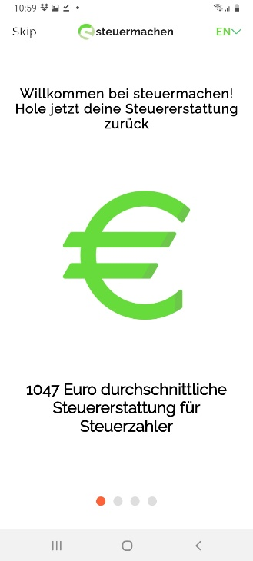 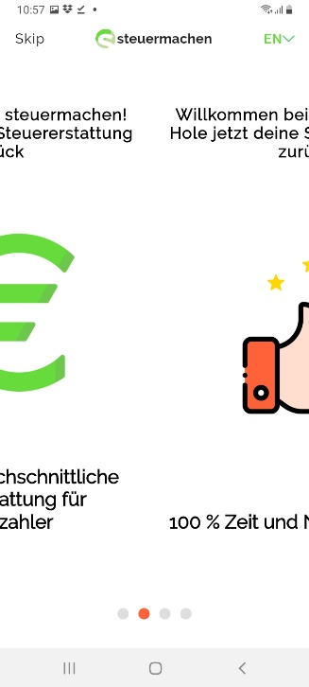

The font and design should look like in Figma

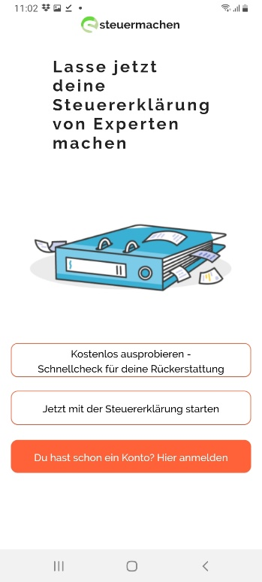

The imprint, data protection and the general terms and conditions must be in PDF format in the app. It may not be forwarded to the website. The imprint data protection and the terms and conditions must also be accessible without Internet

The log in with Apple is missing completely

If you enter the password, you should also make the password visible by a click

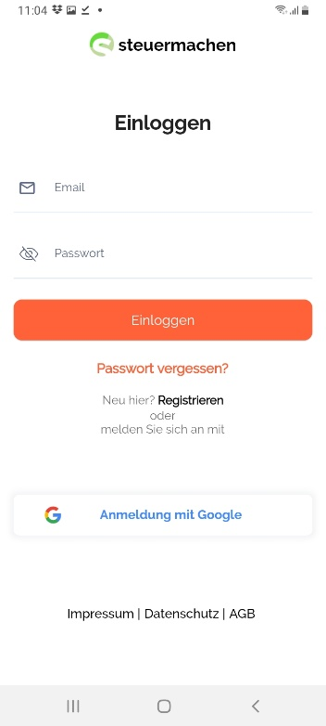

The declaration of consent is missing completely. The hook must be set. The text is in figma

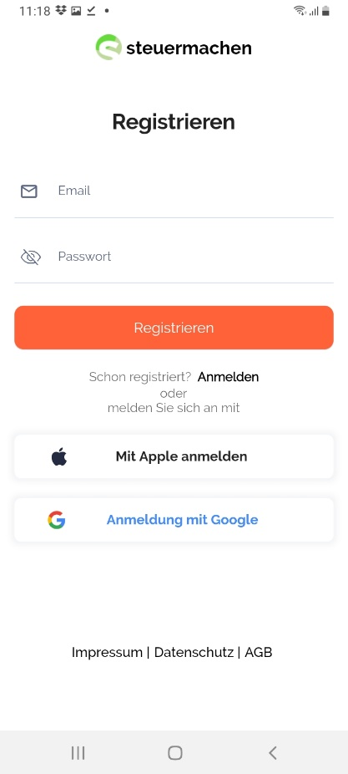

Each page must be in the correct language. The German version can be seen in Figma. The information in the app must also be in the German language. Instead of Phone it’s called “Telefon”. At least one example should be given in the country code (Cell Phone)

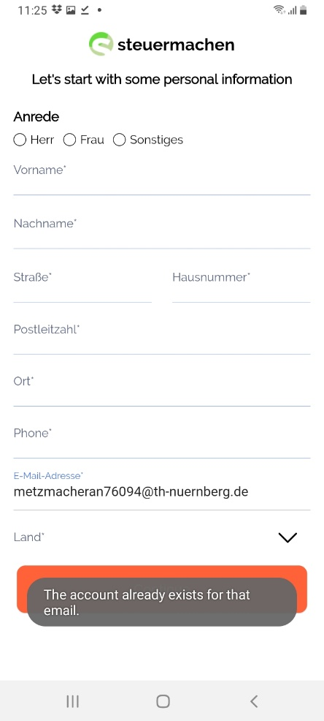

Germany should be pre-selected and at the top of the list.

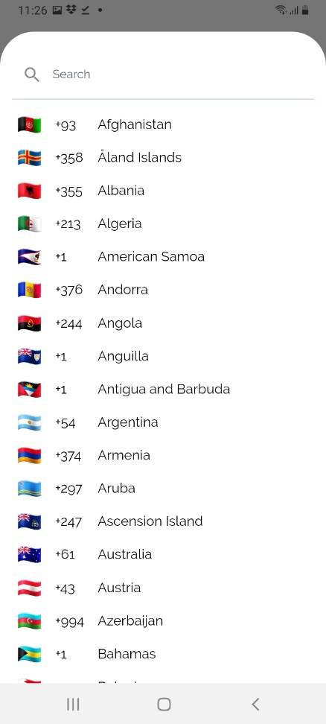

The page should be completely in the correct language. The price calculator is missing. Here the information entered in advance should be taken over and the current price displayed.

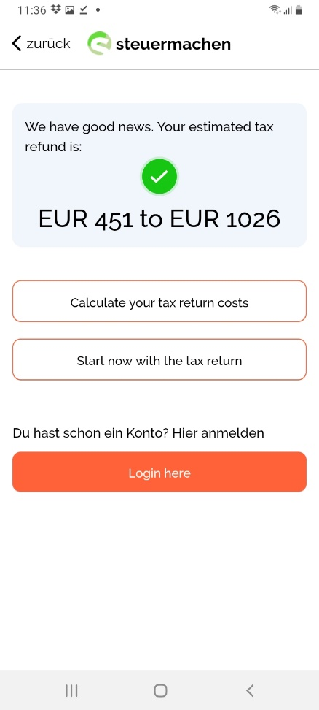

The German version must be displayed. It must give the user the opportunity and motivation to order something.

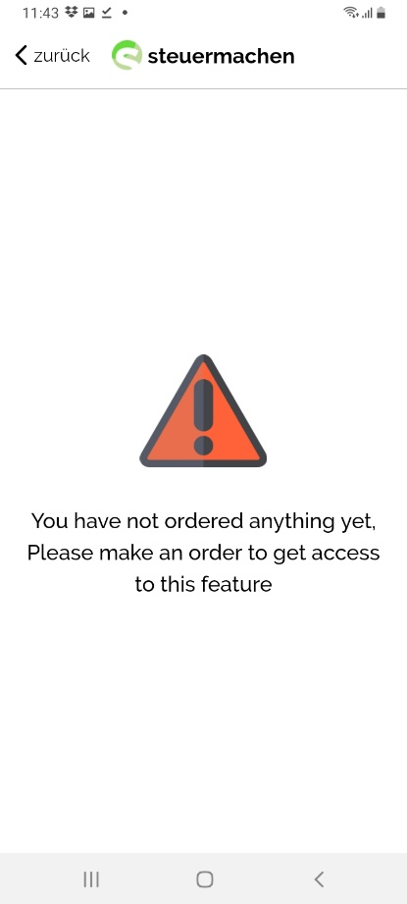

The currency is completely missing. The selection must look more graphic and beautiful. It should be neatly lined up.

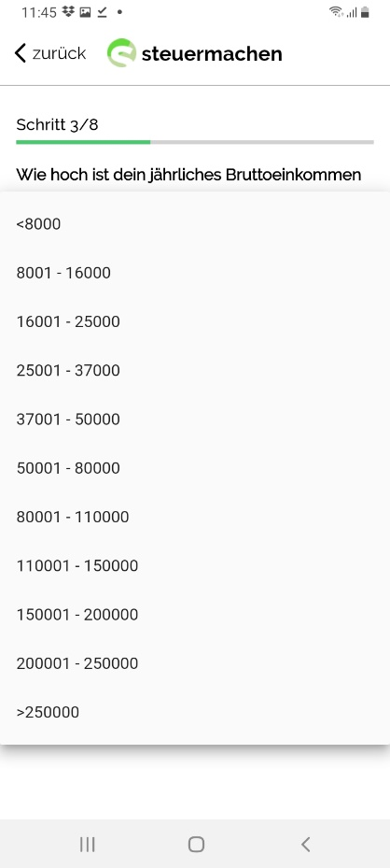

The address should be taken over. The user should not have to enter the address again. However, he can use a new one

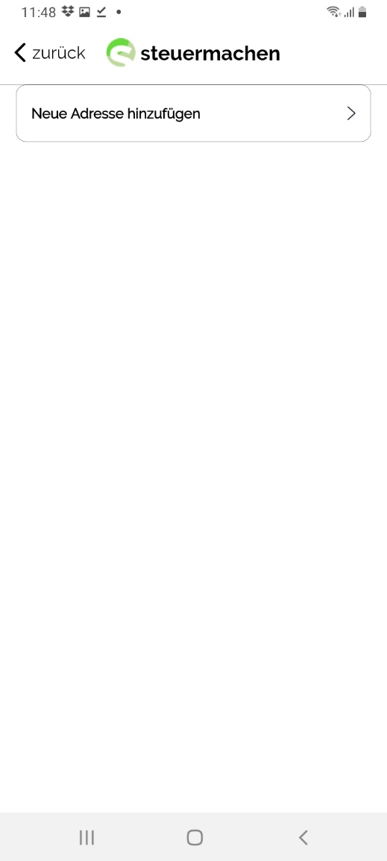

First the street and then the house number is displayed

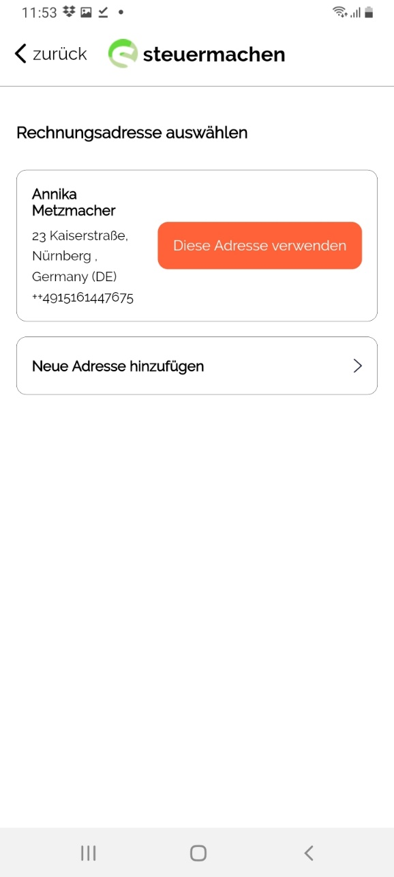

This step is superfluous. It should be deleted

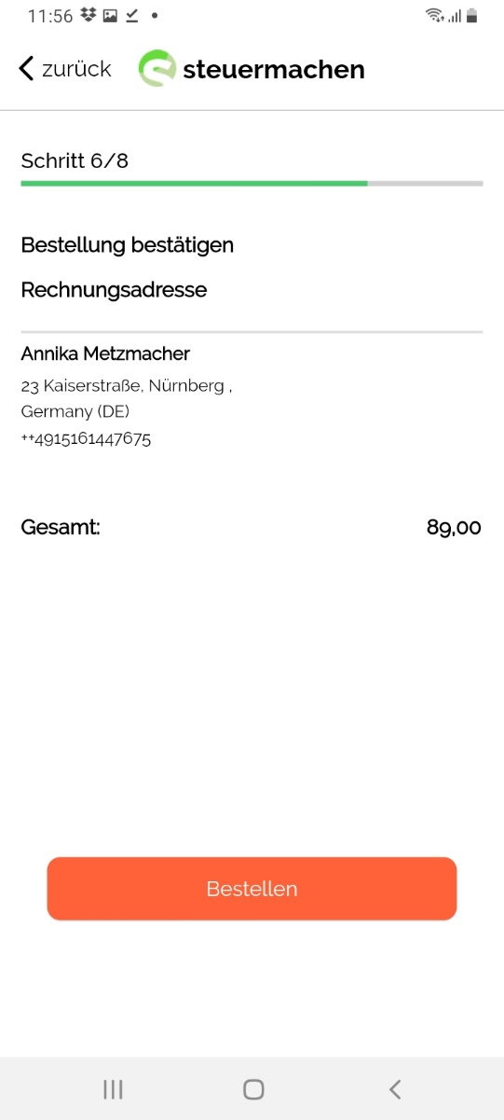

The signature must always be re-entered by the customer each time. The system may not remember this signature and insert it again into the power of attorney. The link with "Bezahlen" must be deleted. It should rather be called "Löschen".

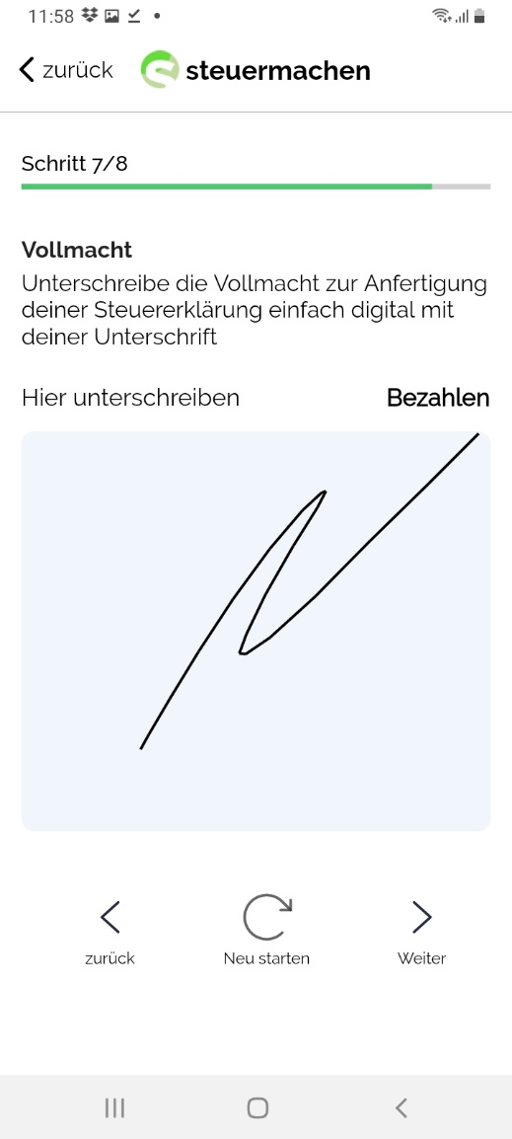

The ticks must always be set by the user himself. They must not be set in advance by the system. The texts must be neatly arranged one below the other. The texts must be in a line with each other so that the text is flush with the text above it. The line spacing should be the same everywhere.

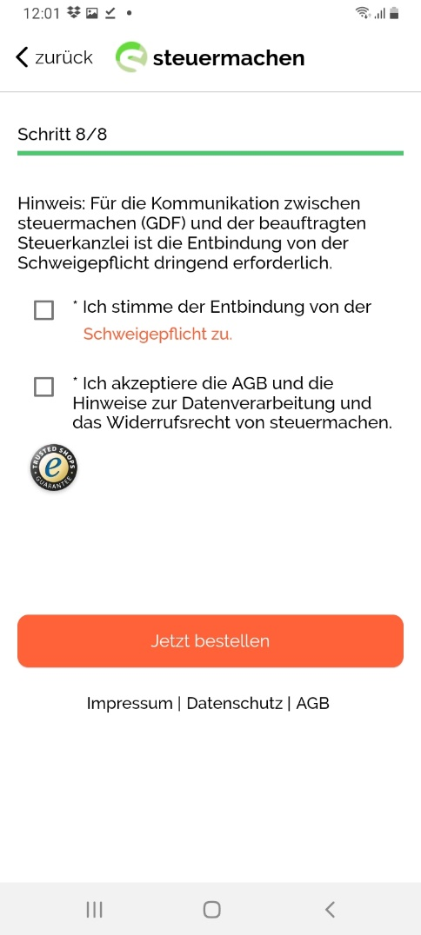

The following pages are missing. The thank you page is missing and the invoices. In addition, no e-mails are sent. The invoices of steuermachen must follow

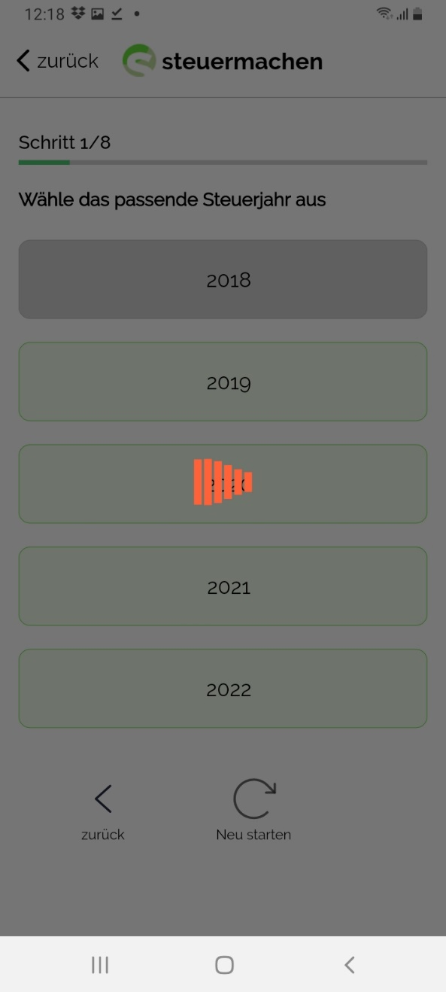

The text is: “Unterschreibe die Vollmacht zur Anfechtung deines Steuerbescheids einfach digital mit deiner Unterschrift“

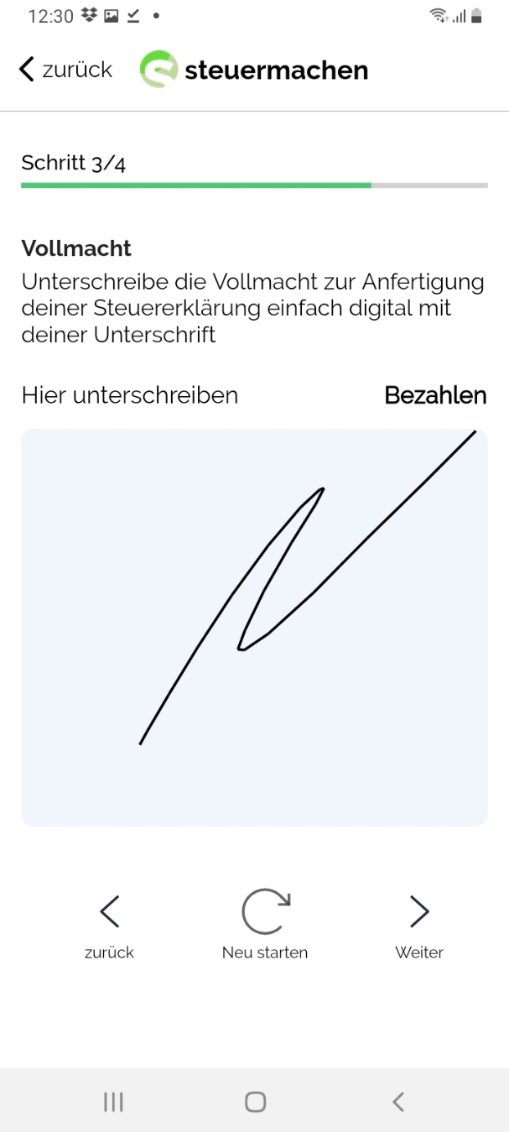

The texts should all be neatly arranged flush with each other. The text should not read “Belege sammeln” but “Steuerbelege sammeln”

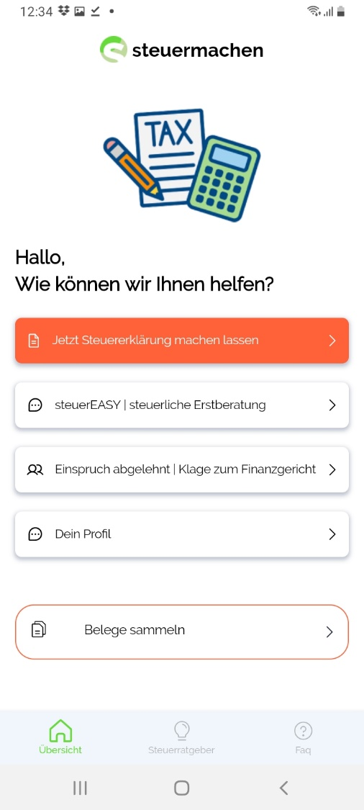

“Produkt” should be used instead of “Steuername”. The product names are then tax return 2020 etc.  
Prices must be quoted in currency. Euro and Brutto must always be indicated.  
Instead of Steuererklärung 2018, it has to be “Bestelldatum”

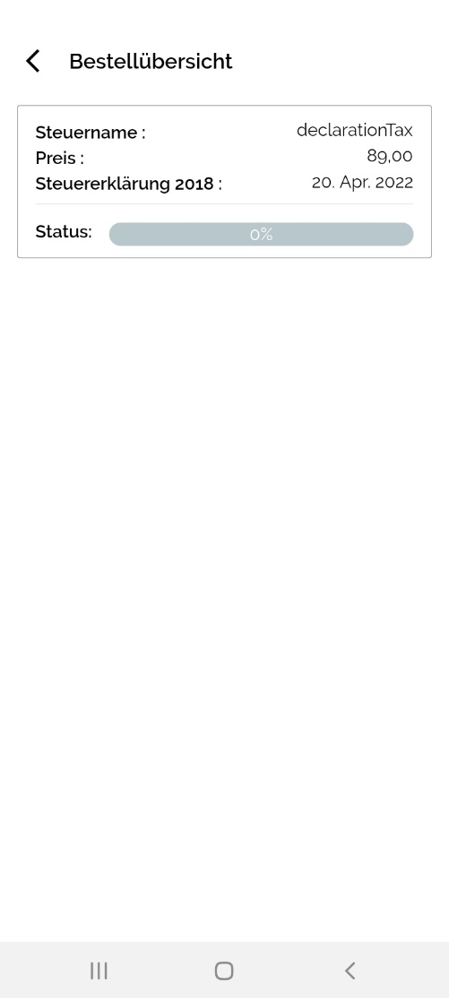

Produkt:

Bestelldatum:

89,00 Euro (inkl. MwSt.)

Steuererklärung 2018

The customer has already decided to use the camera function. The choice is unnecessary.

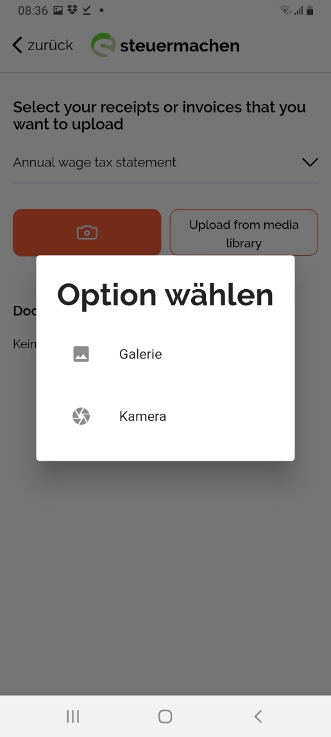

Submitting (“Einreichen”) twice is unnecessary. One of the two options must mean submit (“Einreichen”) and the other must be cancel (“Löschen”)

Ein Bild, das Text enthält.

It is not possible to delete the account. The choices are „Abbrechen“ and “Konto löschen”.

„Bist du sicher, dass du dein Konto dauerhaft löschen möchtest? Deine Daten können danach nicht wiederhergestellt werden.“

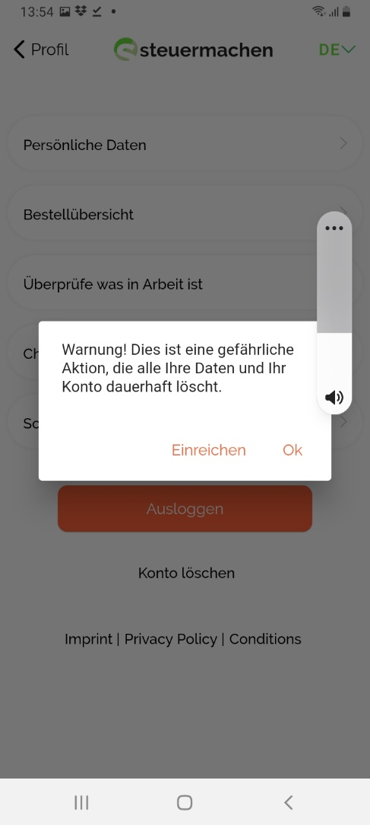

For the articles: the image description is displayed below the images. However, this should not be the case. All articles should be displayed as they can be seen online. In addition, the question is how we solve the problem with the partner programs. Some links may not be displayed in the app. Links in the app cannot be accessed. Some articles cannot be read. In addition, the authors should be displayed as in the website.

The button should be called: "Jetzt beauftragen" (Engl.: Order now)

The video does not load

Can the links be removed so that you do not try to get to the links

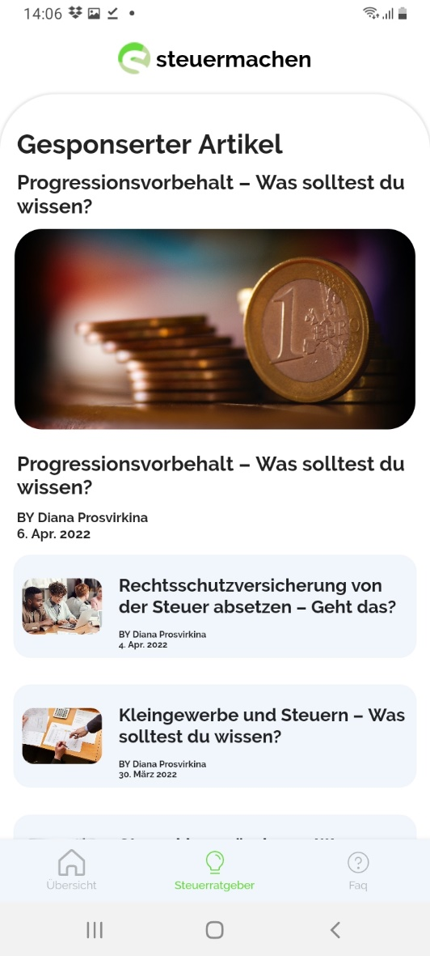

Steuerratgeber

The texts for the FAQs should be taken over from the Word document

